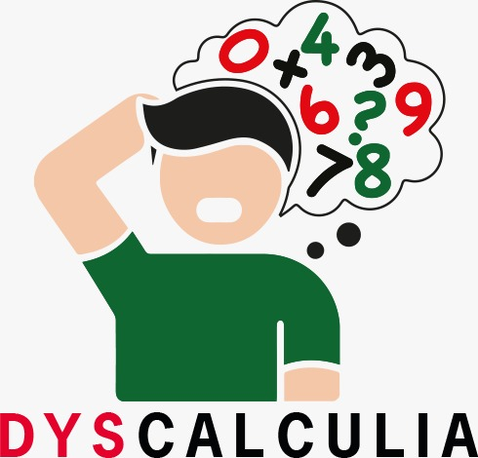**Change Your Perspective:**

**It's Just Dyscalculia**

**Content**

*Month 2023*

Provided by Institution

**Acronym**: Dyscalculia

**Reference Number**: 2022-1-TR01-KA220-SCH-000088738

**Project Duration**: 31.12.2022 - 30.12.2024

**Project Partners**: Cukurova District Directorate of National Education, Turkey

University Paderborn, Chair Business Education II, Germany

University Cukurova, Turkey

AGIFODENT, Spain

Dalya Agency, Turkey

Zemynos Panevezios, Lithuania

Headline 1

Headline 2

Headline 3